**Store Management System**

**21BLC1452 Preetam Kalyaan**

**Creating the tables with constraints:**

**Item master:**



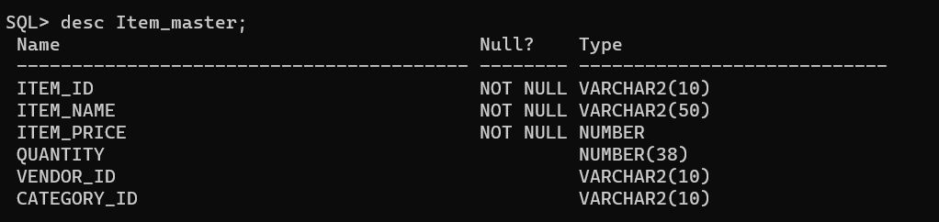

**Category:**



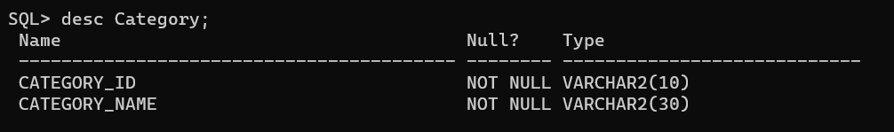

**Customer:**

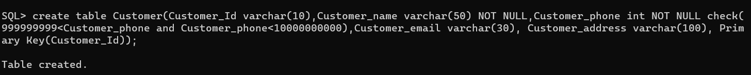

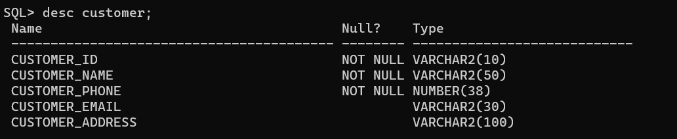

**Vendor:**

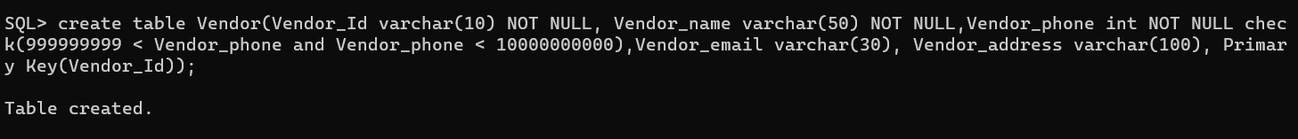

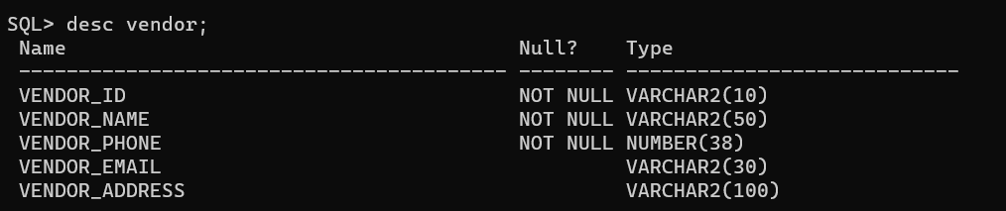

**Order Master:**

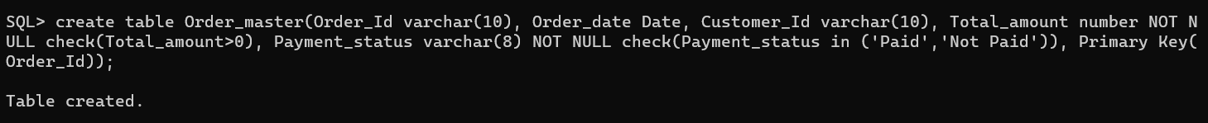

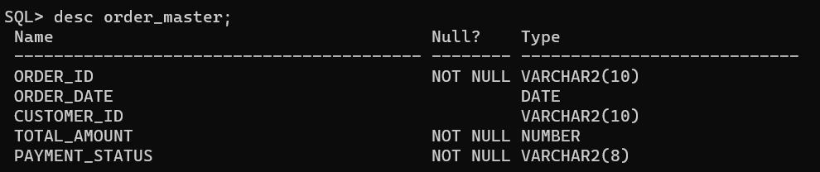

**Order details:**



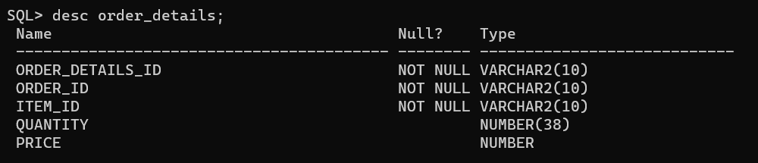

**Linking the tables:**

**Linking Item master and Vendor tables using foreign key approach:**



**Linking Item master and Category tables using foreign key approach:**



**Linking Order master and Customer tables using foreign key approach:**



**Linking Order details and Order master tables using foreign key approach:**



**Inserting values into the tables:**

**Item Master:**

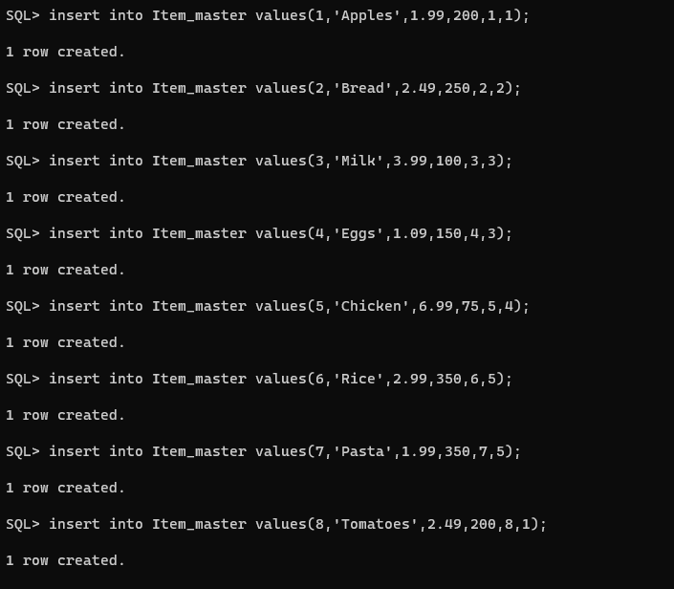

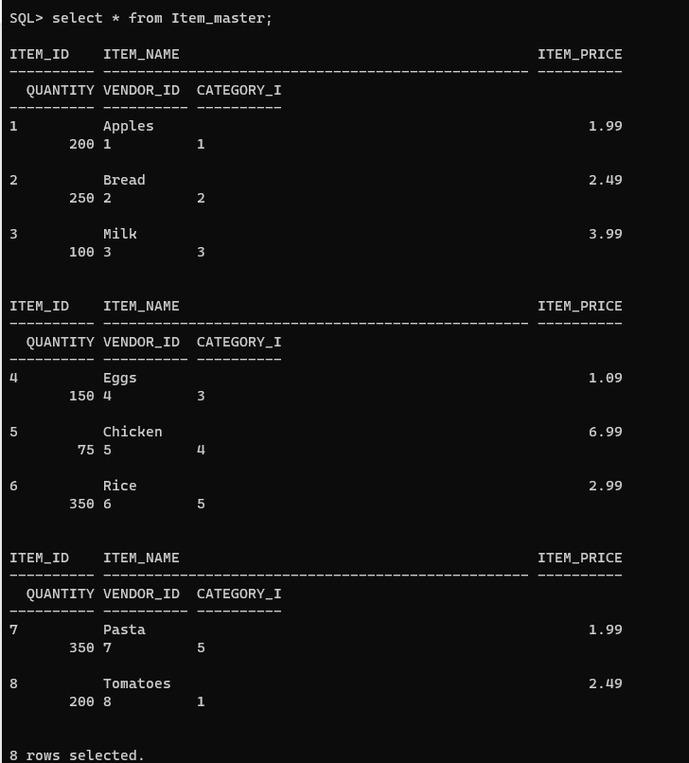

**Category:**

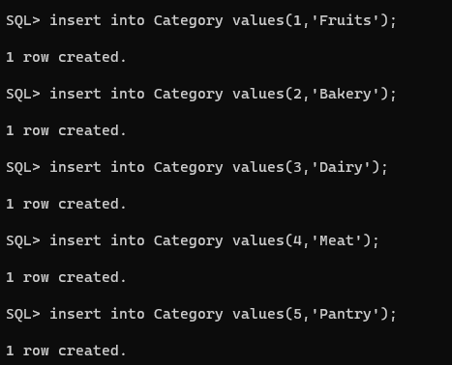

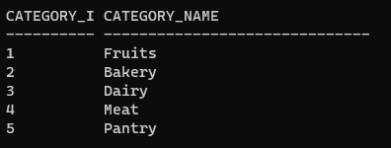

**Customer:**

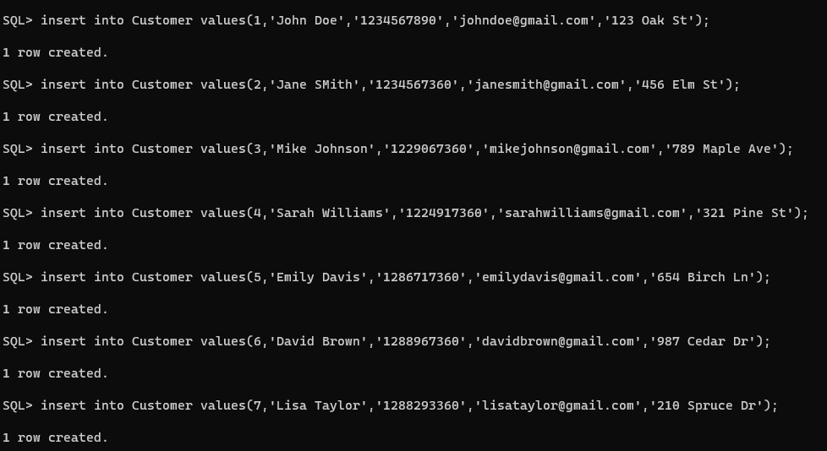

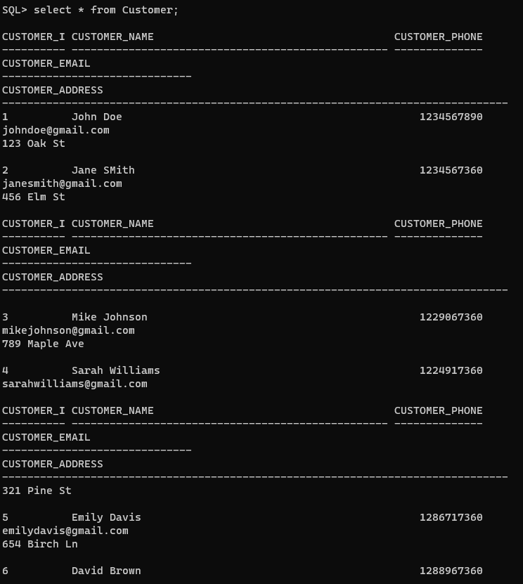

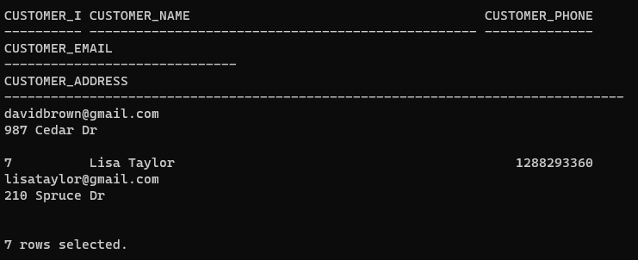

**Vendor:**

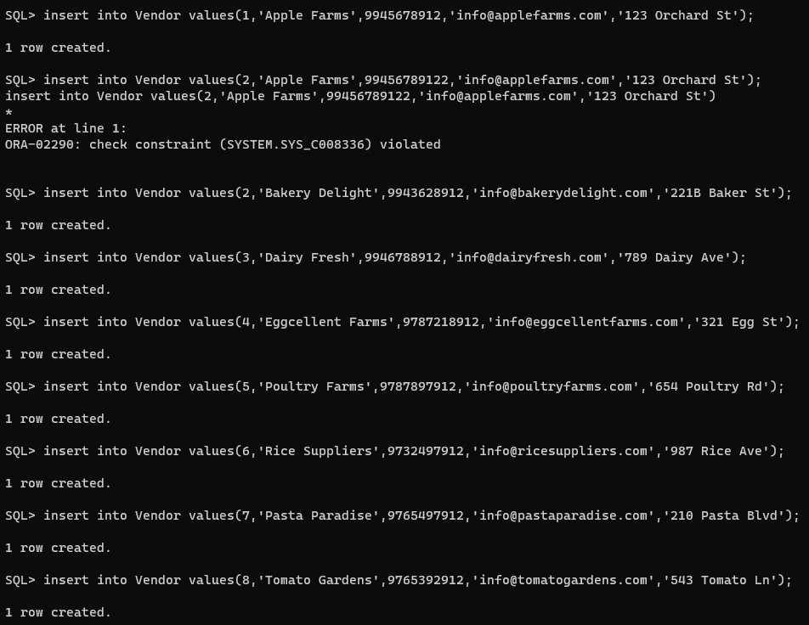

Here we can see that the first number was not accepted as it didn’t adhere to the constraints set on that column(Phone number should have 10 digits).

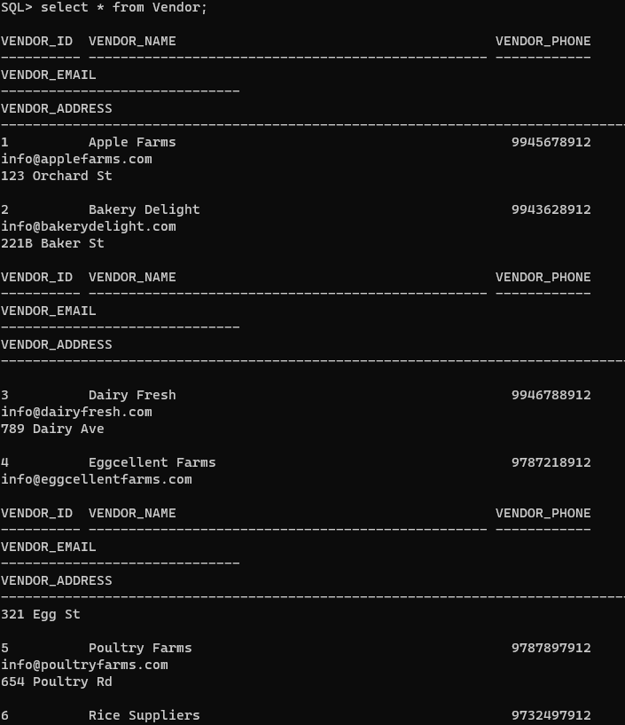

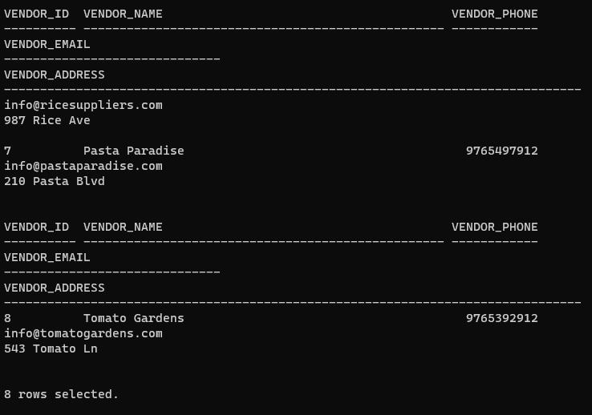

**Order Master:**

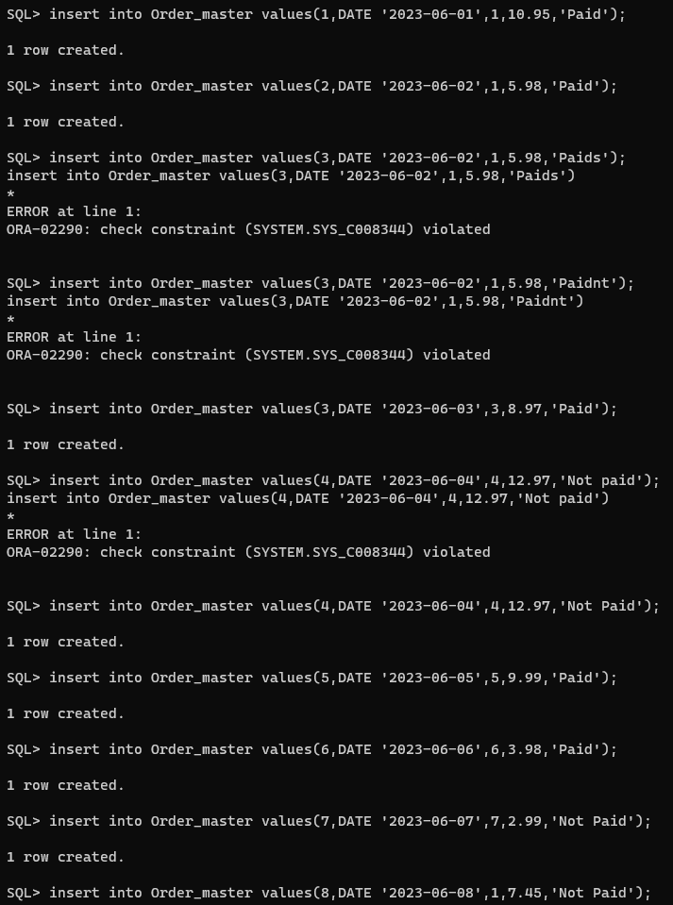

Here we can see that no other values other than ‘Paid’ and ‘Not Paid’ can be entered into the Payment Status field.

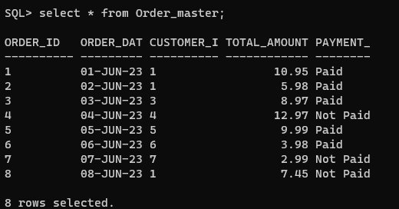

**Order details:**

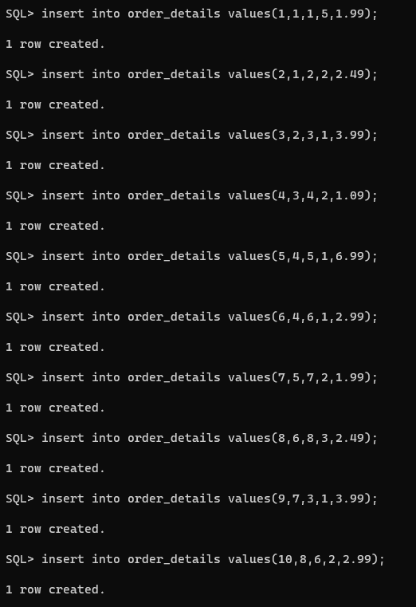

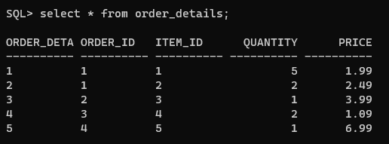

**SQL Triggers:**

**Trigger to display error message whenever an item order is higher than the available inventory:**

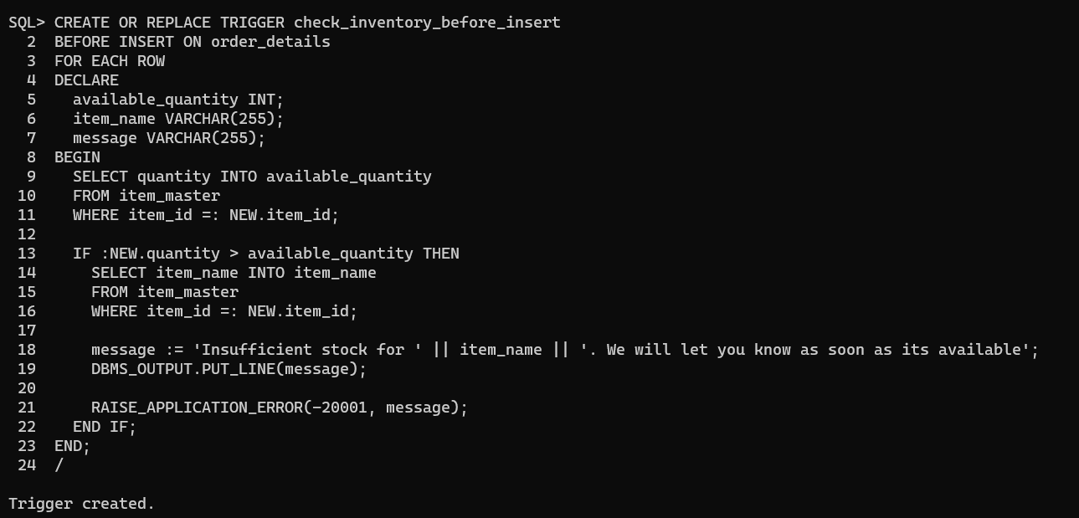

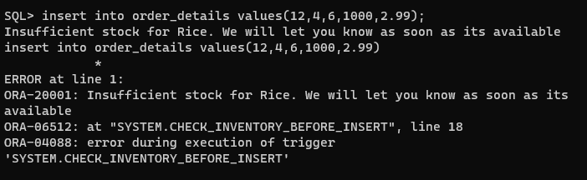

An error is raised and the value will not be inserted into the table delivering an error message.

**Trigger to automatically reduce inventory value when an order is placed:**

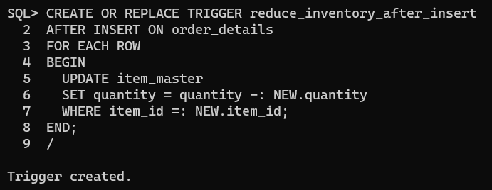



Here we can see that the quantity for the item ‘Rice’ is 350.

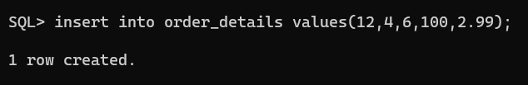

Now we raise a new order for rice for a quantity of 100.

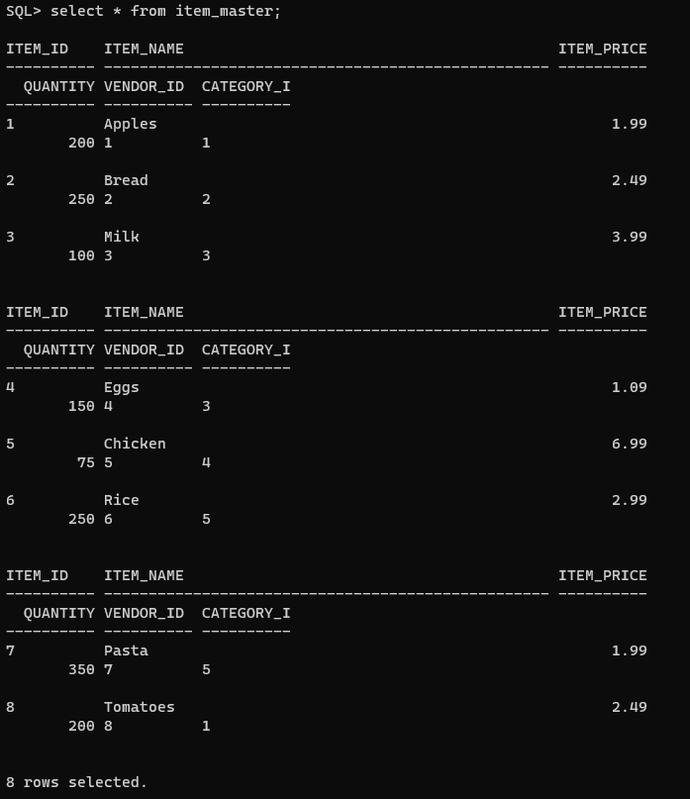

We can see that the quantity of rice has been reduce down to 250 now.

**Trigger to set the value for vendor id in item master as null if said vendor is deleted from the vendor table:**

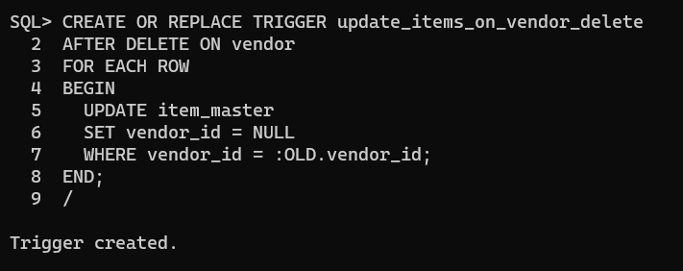

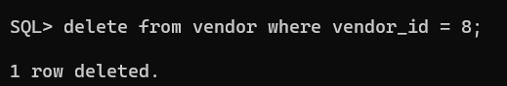

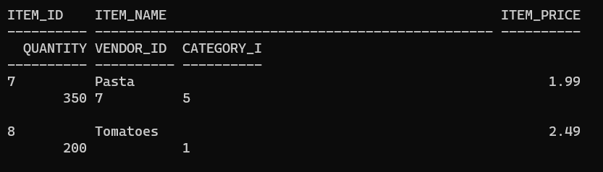

As you can see, the vendor id column is set to NULL when the corresponding vendor is deleted from the vendor table.

**Trigger to prevent duplicate categories:**

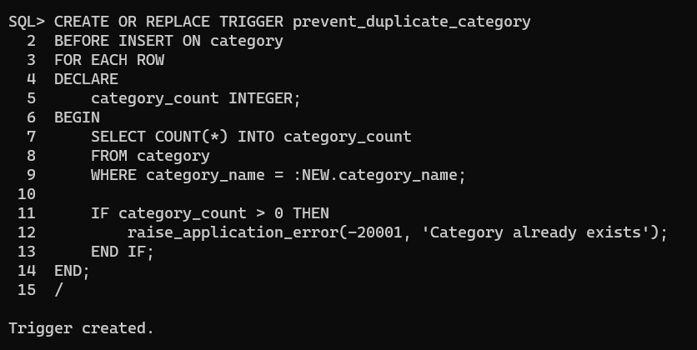

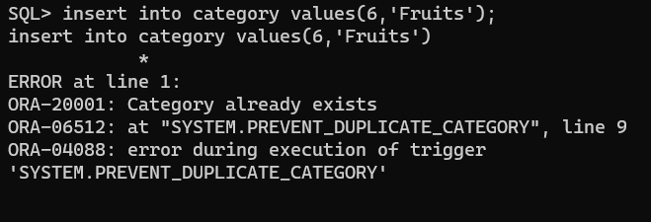

Here we can see that an error message ‘Category already exists’ pops up when duplicate entry is detected.

**Trigger to raise error when invalid item id is ordered:**

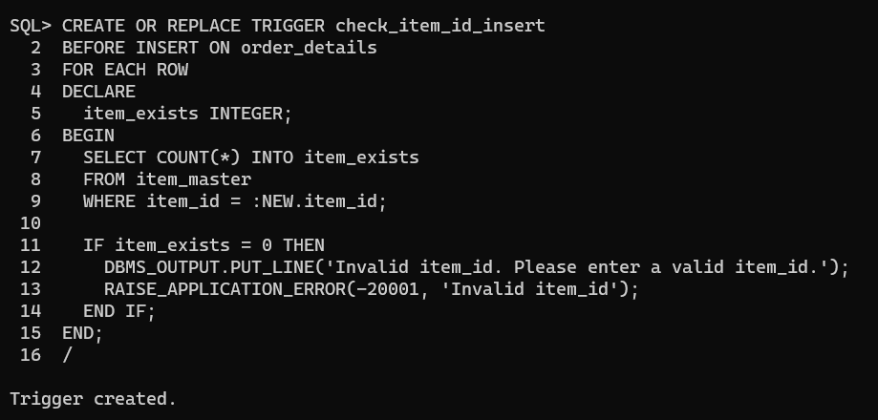

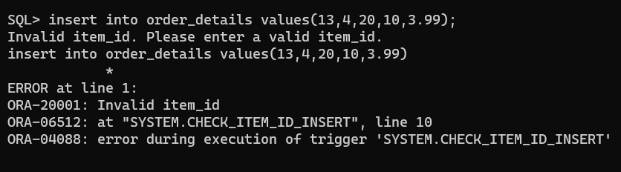

An error is raised when invalid item id is ordered.

**Trigger to raise error when invalid customer id is entered:**

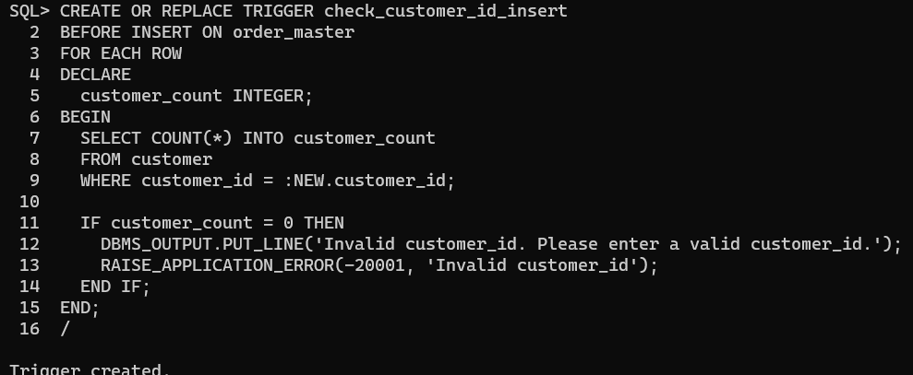

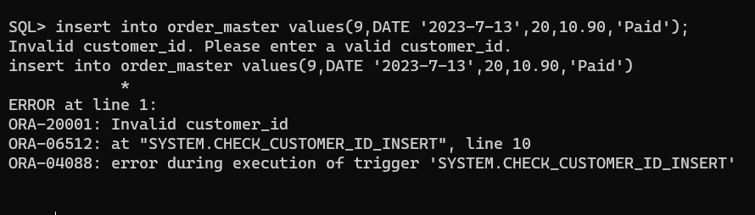

Here we can see that when an invalid customer id is used to place an order, an error is raised.